**MultiVagrant file!**

**MULTIPLE VM IN A VAGRANTFILE**

* Copy the code from the link: <https://developer.hashicorp.com/vagrant/docs/multi-machine>

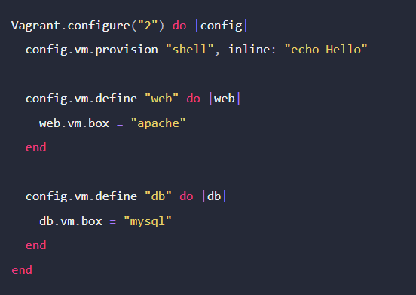

* Paste the code in Notepad++ and add the ram, network and other settings
* Create a new directory and save the notepad++ there

(mkdir multivm)

Filename: vagrantfile

Filetype: all types

Example:

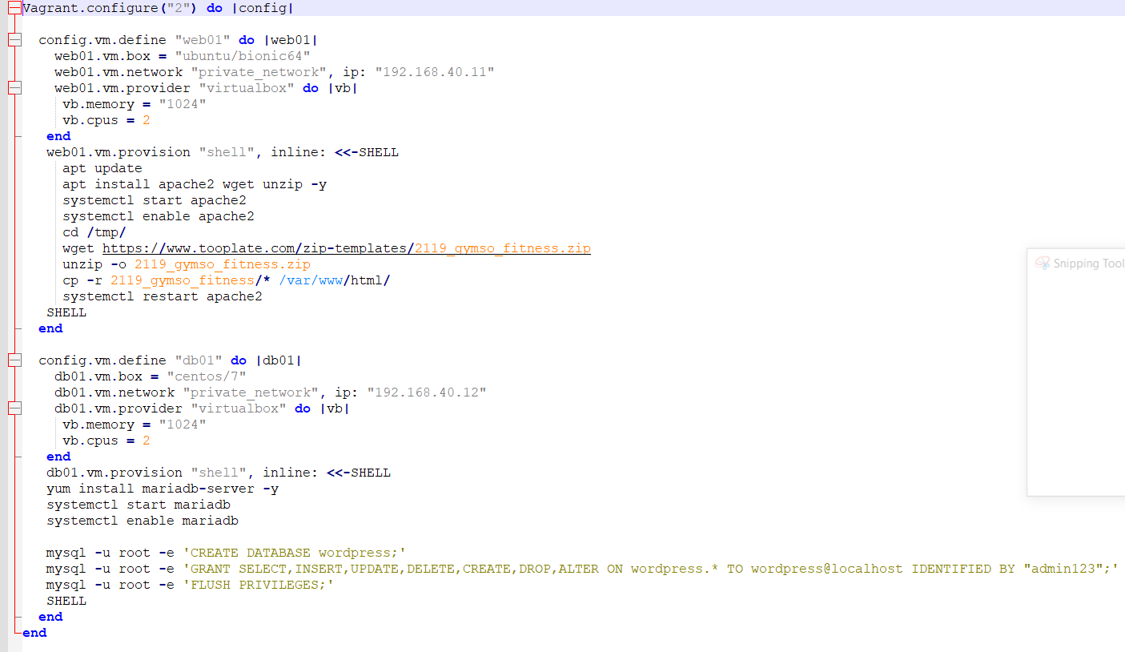

vagrant up (powers up all vms)

vagrant up web01 (powers up only the web01)

vagrant ssh web01 ….. follow the trend!Page of